**Blood Bank Management System**

**Purpose:**

The System provide information of blood bank. Users, Donors and Organizations information would be managed by Admin. The purpose of blood bank management system is to simplify and automate the process of searching for blood in case of emergency and maintain the records of blood Donors.

**Modules:**

**1)Admin**

**2)User**

**3)Donor**

**4)** **organization**

**Functional Requirements:**

**1)Admin**

-Manage the Registration of users ,donors and organization.

-View User/Donor and organization information.

**2)User**

-Check the blood availability.

-Register

-login

-Post the blood request

**3)Donor**

-Register

-login

-Book an appointment to donate blood.

**4)** **organization**

**-**registration

**-**login

**-**Schedule the blood donation campaign.

**Non-Functional Requirements:**

**1)Availability-**

-Users & Donors can access this management system from anywhere from this web application.

-In case of Hardware failure or database problem all backups plan should be available.

**2)Security-**

-Users and Donors information should be kept confidential under security system.

-The system automatically logs out after the period of inactivity.

**3)Reliability-**

-System will be reliable enough to provide intact information about to user and donor.

-Once the blood is donated or request for blood is post user or donor will receive the notification on the same.

**4) Performance-**

-Basic system configuration is enough to access the web application.

-Users and Donors can access the web application from mobile phones with minimal performance of the same.

-Performance of the system remains same regardless of platform either it is laptop or mobile phone.

**Data Flow Diagrams-**

**1.Zero Level Data Flow Diagram [0 Level DFD] of Blood Bank Management System:**

This is the Zero Level DFD of Blood Bank Management System, where we have elaborated the high-level process of Blood Bank. It’s a basic overview of the whole Blood Bank Management System or process being analysed or modelled. It’s designed to be an at-a-glance view of Admin, User, Donor and organization showing the system as a single high-level process, with its relationship to eternal entities of blood group.it should be easily understood by a wide audience.

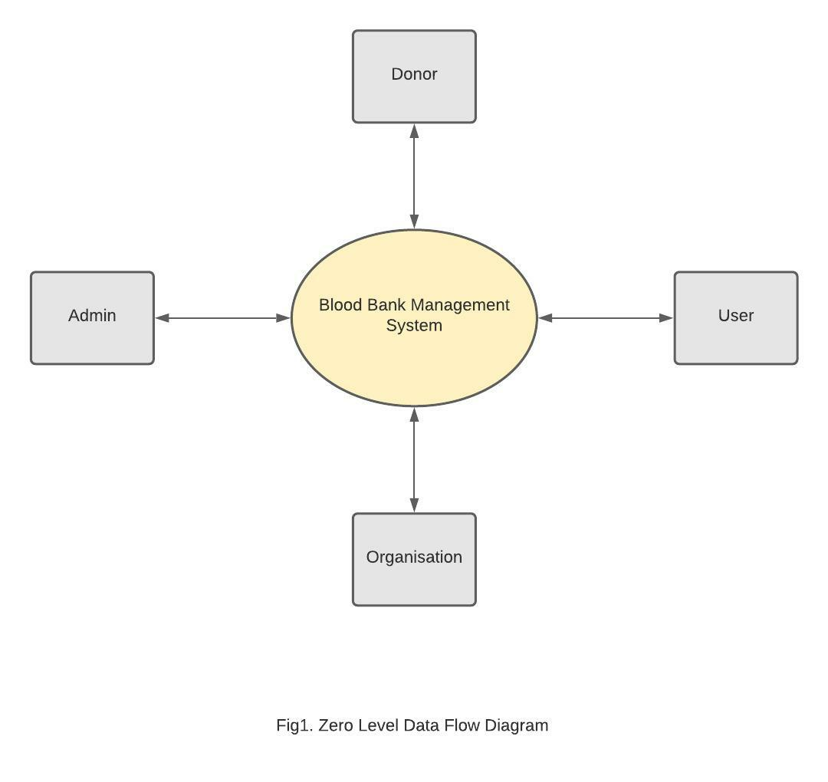

**2.First Level Data Flow Diagram [1st Level DFD] of Blood Bank Management System:**

First Level DFD [1st Level DFD] of Blood Bank Management System shows how the system is divided into sub-systems(processes), each of which deals with one or more of the data flows to or from an eternal agent, and which together provide all of the functionality of the Blood Bank Management System as a whole.it also identifies internal data store of User, Donor, Blood Stocks and Organizations.

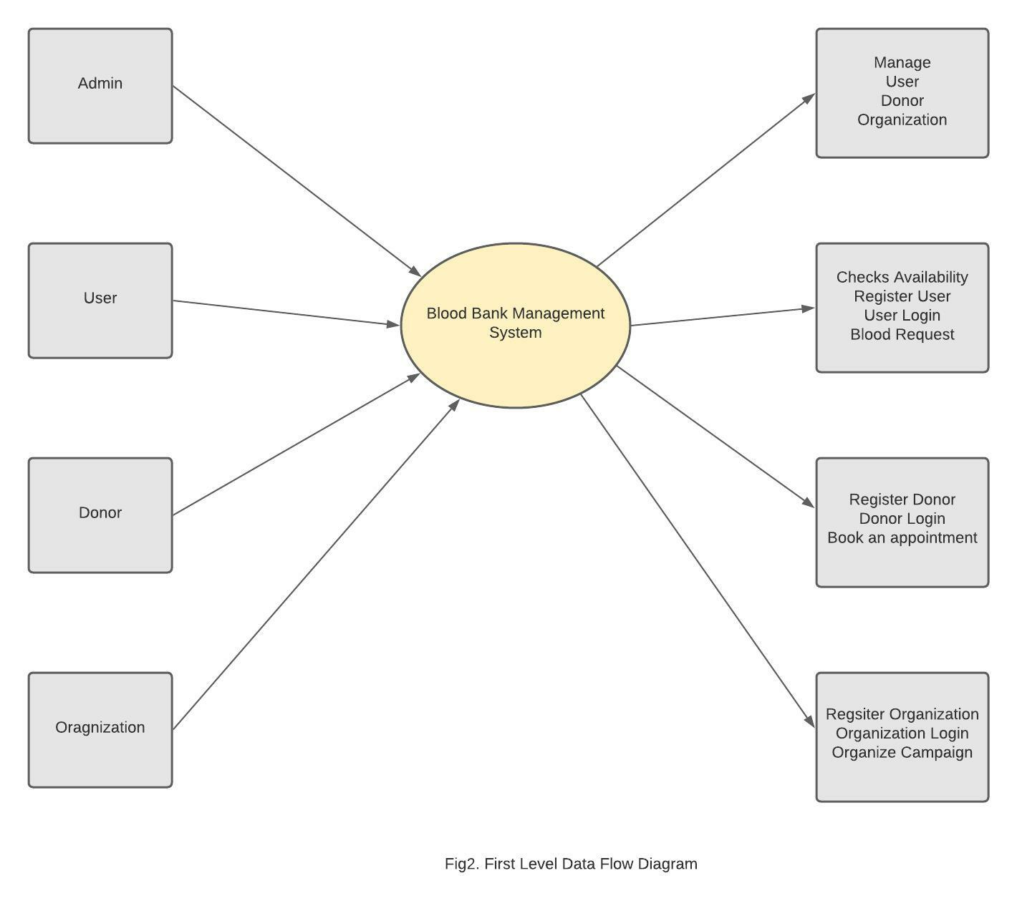

**3.Second Level Data Flow Diagram [2nd Level DFD] of Blood Bank Management System:**

DFD Level 2 then goes one step deeper into parts of Level 1 of Blood Bank. It may require more functionalities of Blood Bank Management to reach the necessary level of details about the Blood Bank functioning. First level DFD of BBMS shows how the system is divided into sub-systems. The 2nd Level DFD contains more details of User, Donor and Organization.

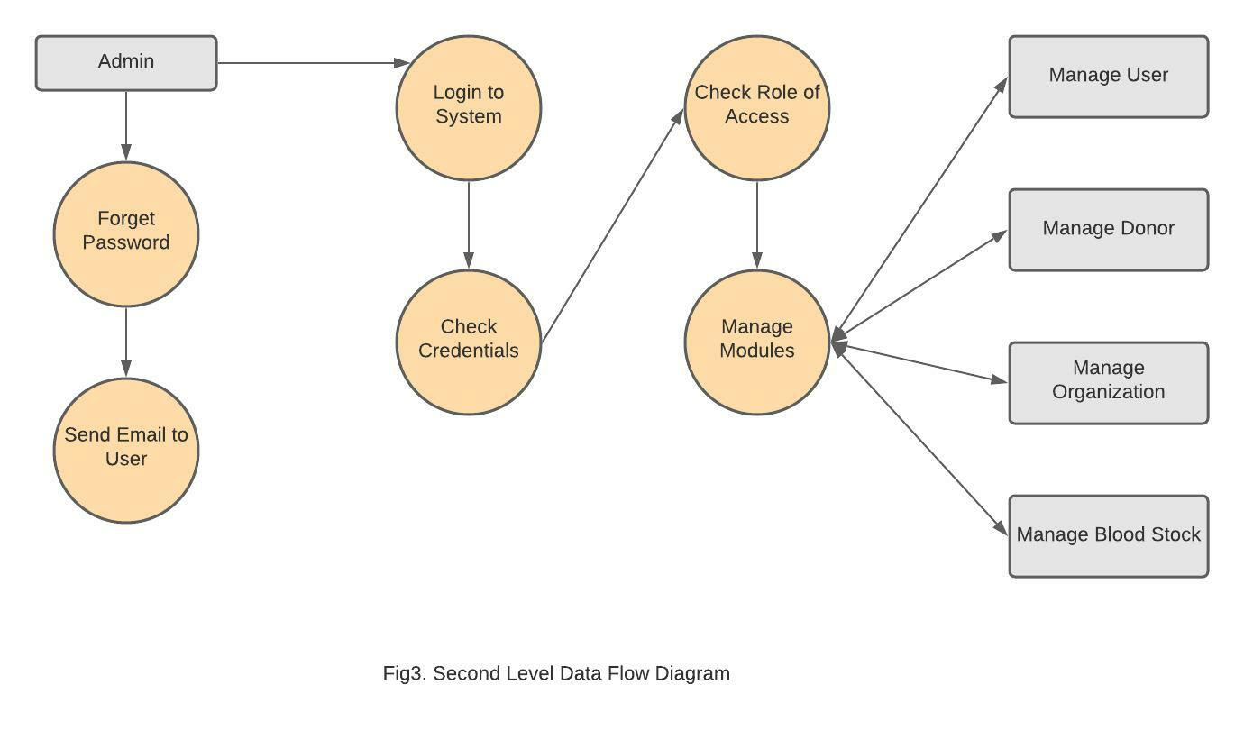

**Blood Bank Management System Activity Diagram-**

This is Activity UML diagram of Blood Bank Management System which shows the flows between the activity of stocks, user, donor and organize.

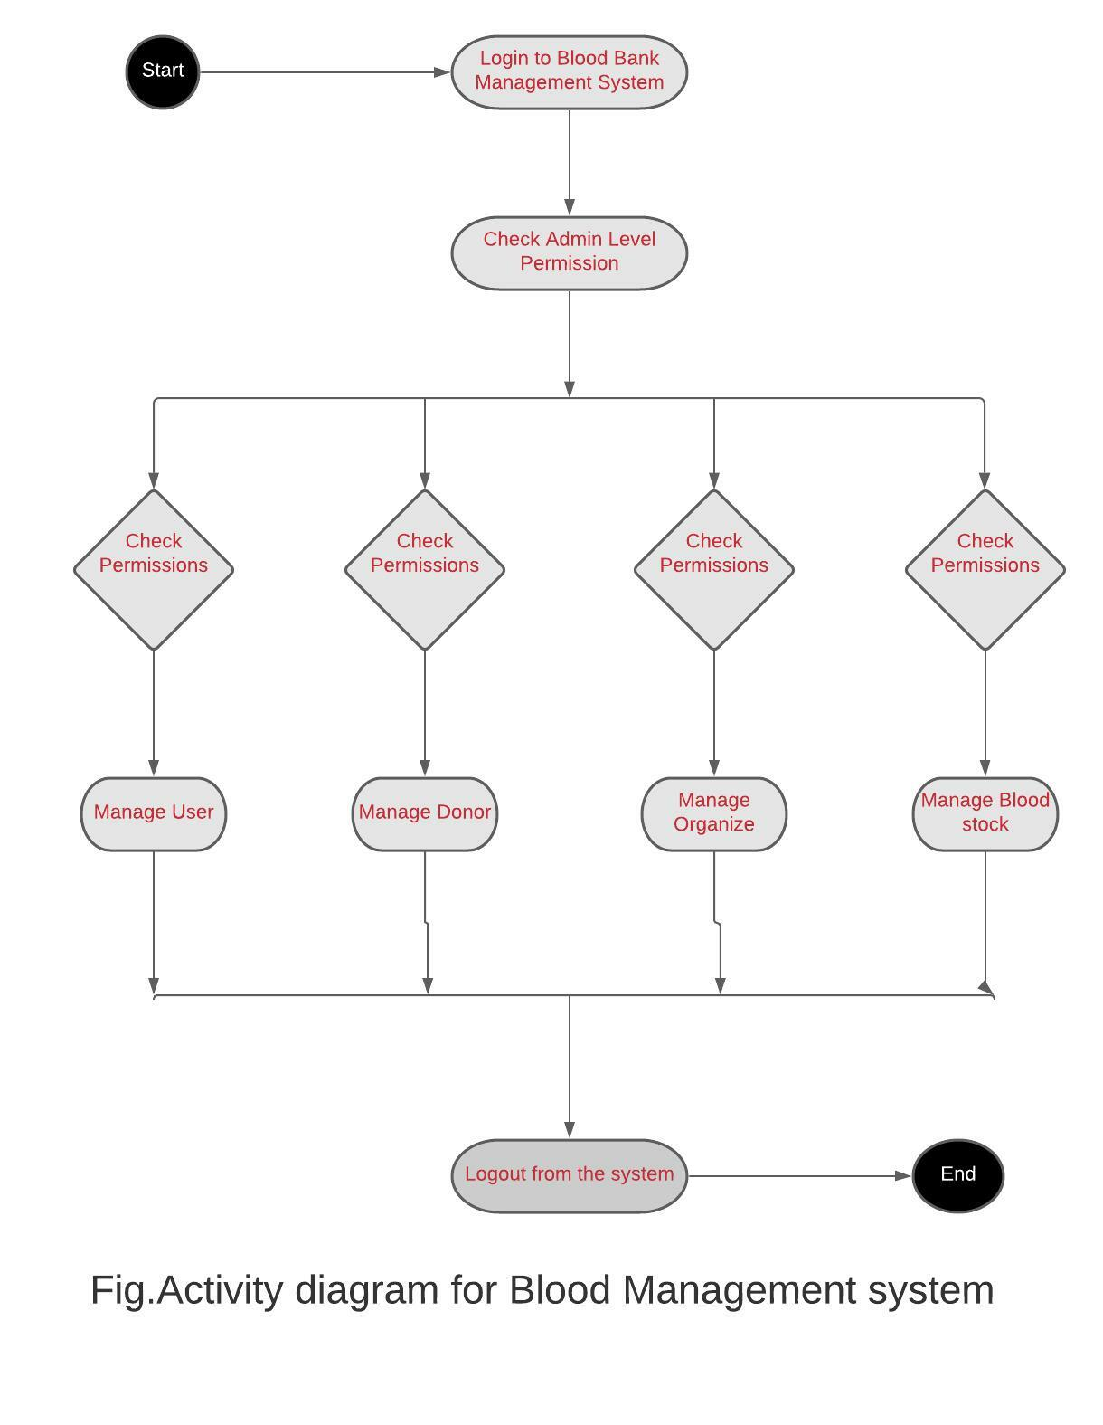

**Use Case Diagram-**

This use case Diagram is a graphical depiction of the interactions among the elements of Blood Bank Management System. It represents the methodology used in the system analysis to identify, clarify and organize system requirements of Blood Bank Management System. The main actors of Blood Bank Management System in this Use Case Diagram are: Admin, User, Donor and organizations who perform the different types of use cases shown on the picture below.

**1.Admin-**

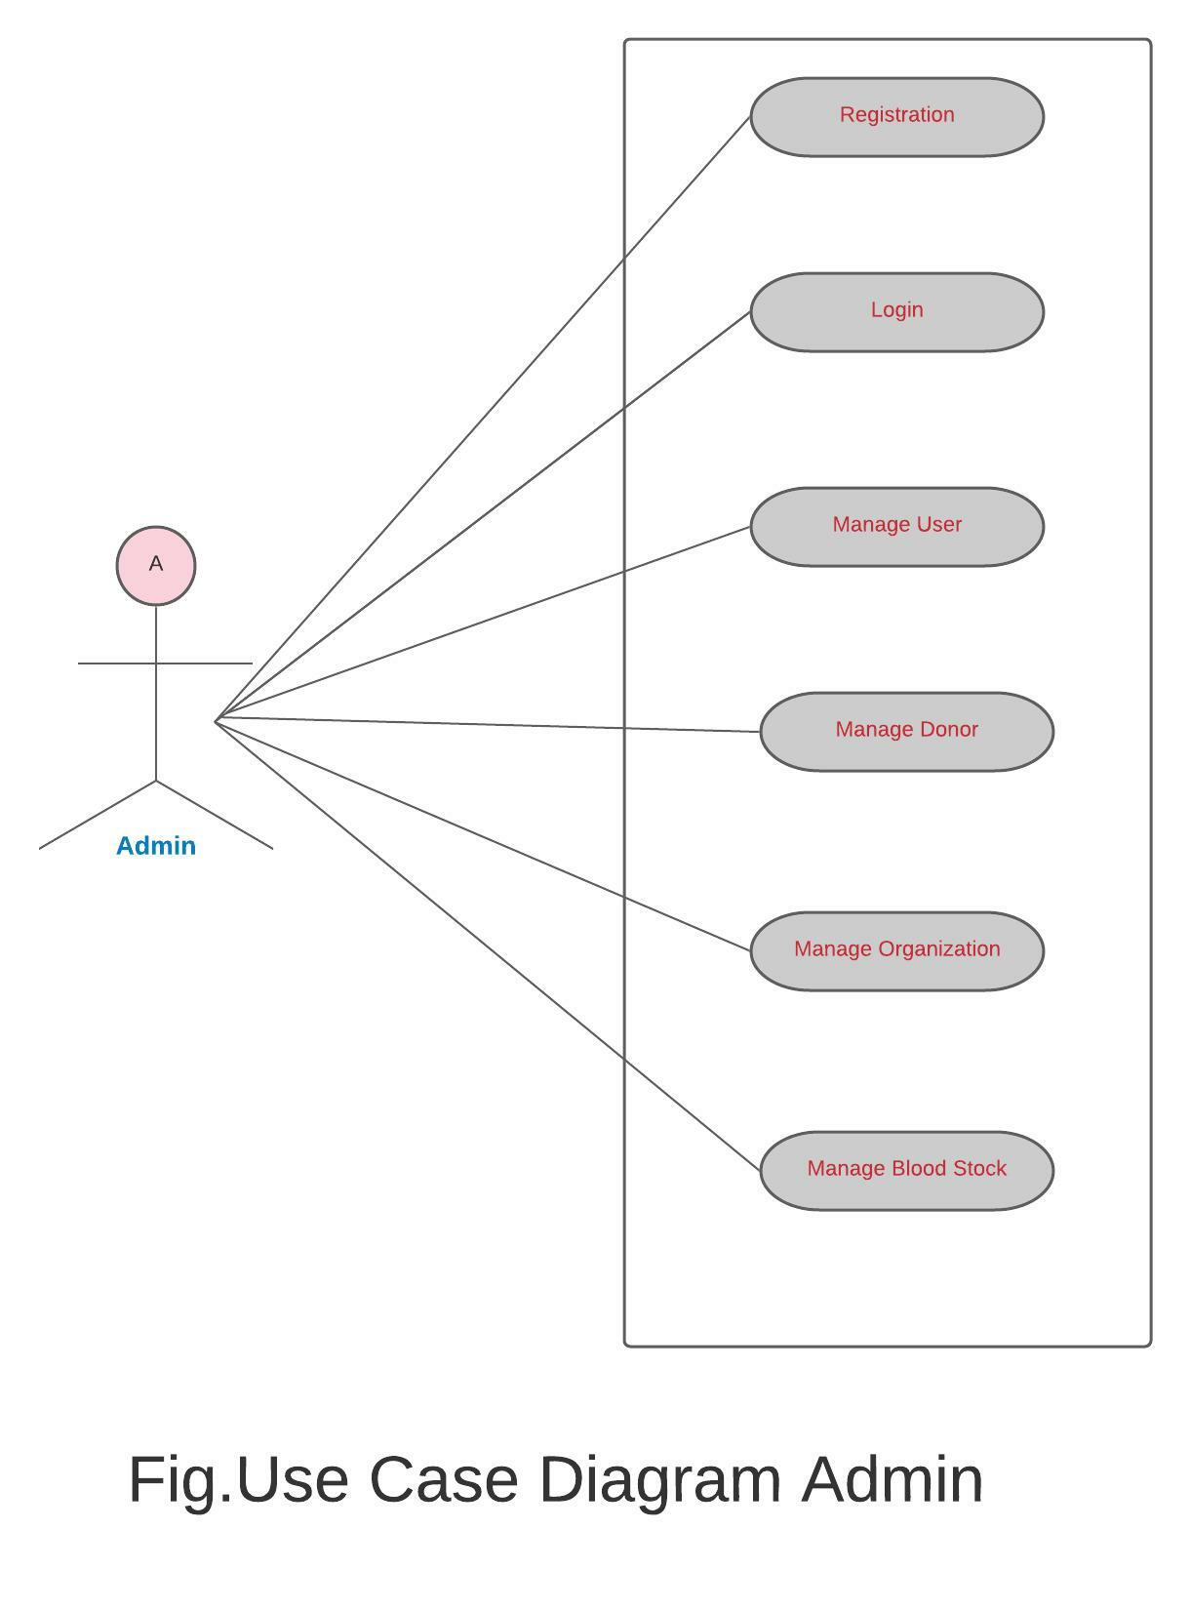

**2.User-**

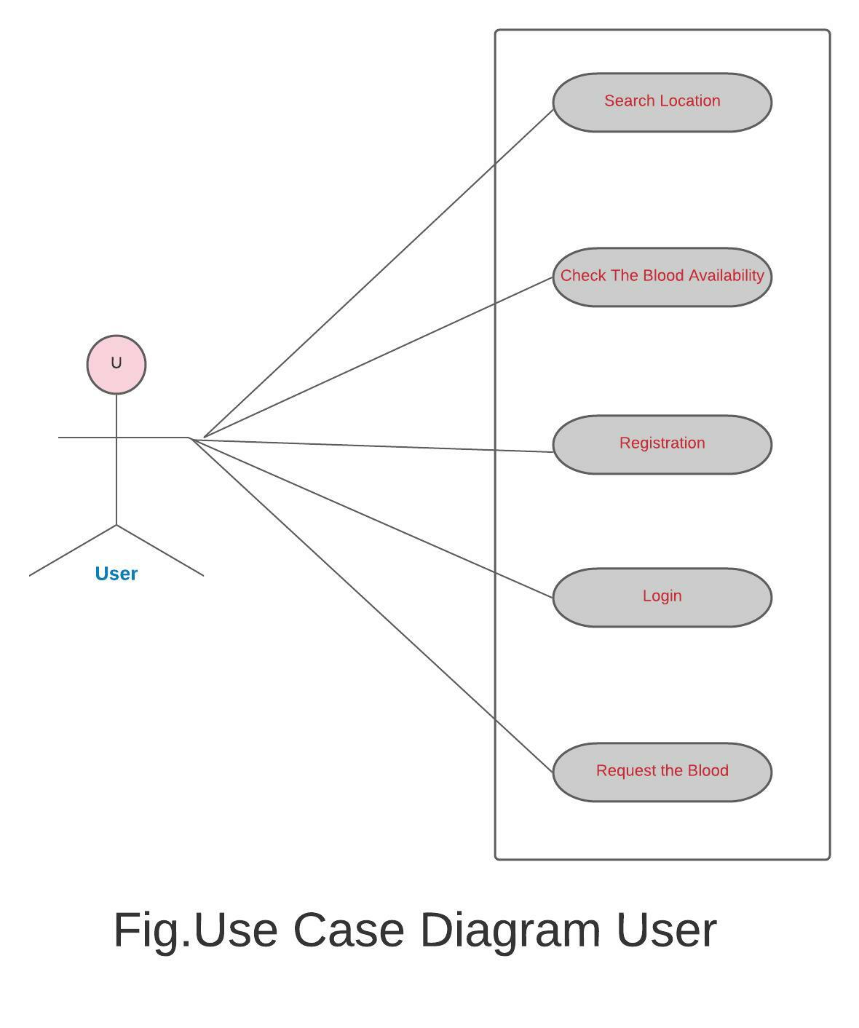

**3.Donor-**

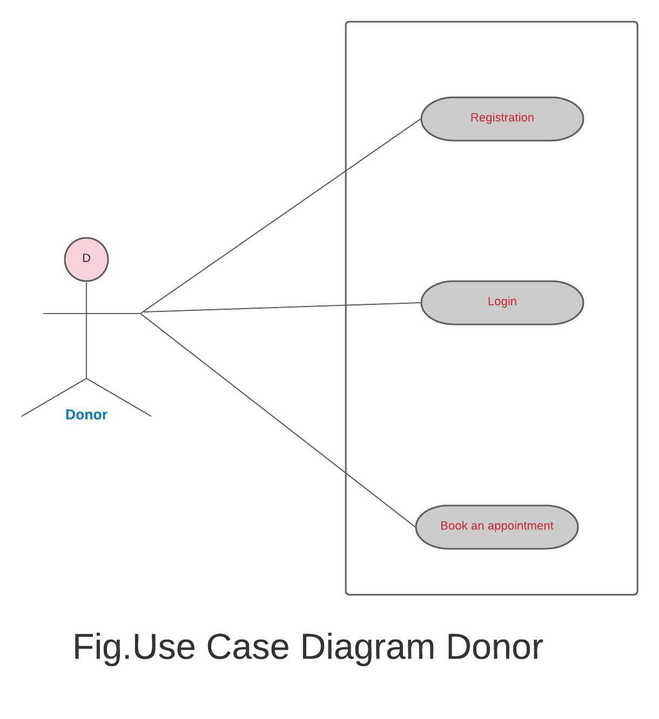

**4.Organize-**

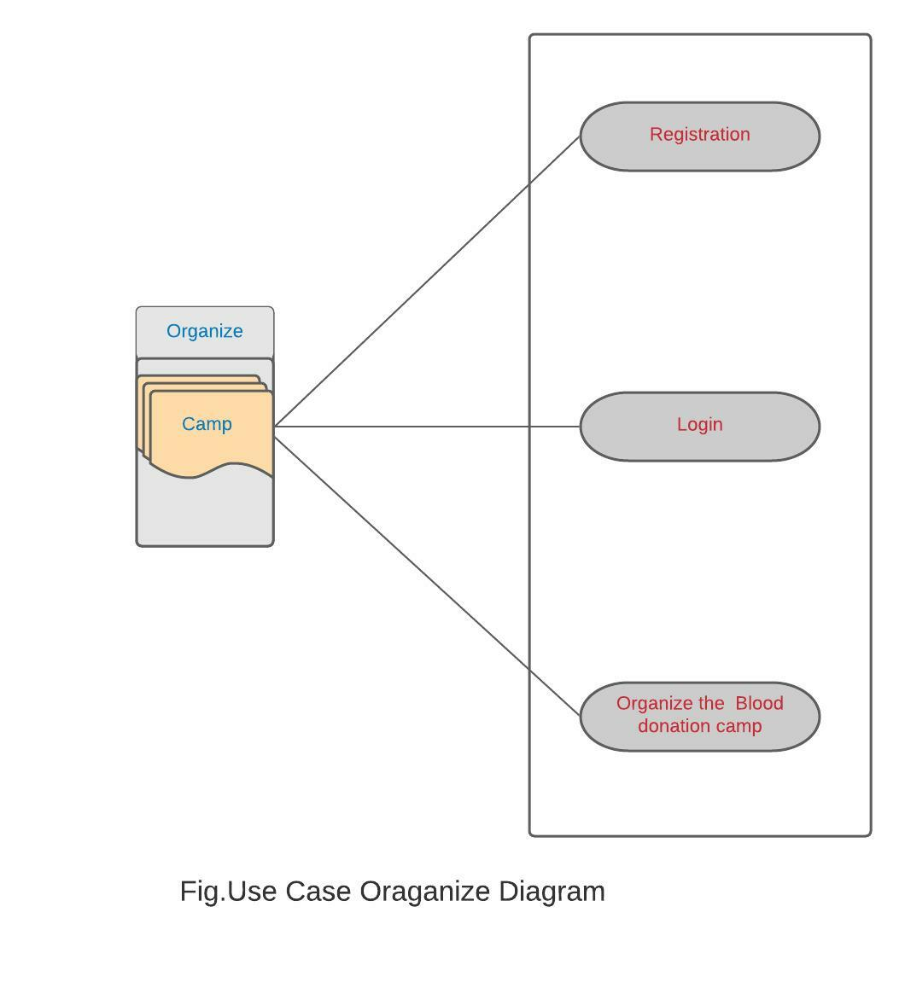

**Blood Bank Management System ER Diagram-**

This ER (Entity Relationship) Diagram represents the model of Blood Bank Management System Entity. The entity-relationship diagram of Blood Bank Management System sows all the visual instrument of database tables and the relations between Admin, User, Donor, Organization and Blood stocks etc. It used structure data and to define the relationship between structured data groups of Blood Bank Management System functionalities.

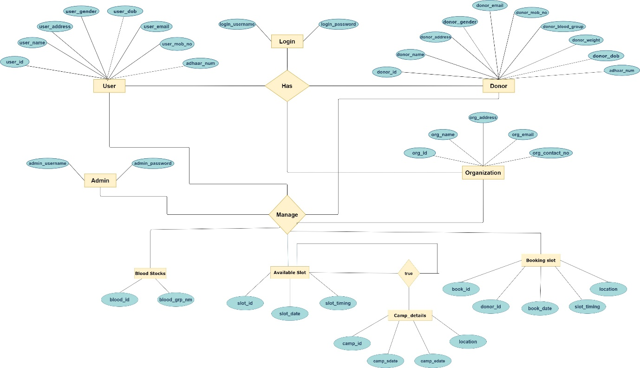

Fig. E-R Diagram